Potential Color Palettes

Sunset Palette
Colors and their Hex
#DEA193 – Rose Gold
#6a0d83 – fuchsia
#ce4993 – Bubble Gum Pink
#ee5d6c - Salmon
#eeaf61 – Golden Yello
#517BCC – True Blue
#142E57 – Navy Blue
#FFFFFF – White
#000000 - Black

Image inspiration
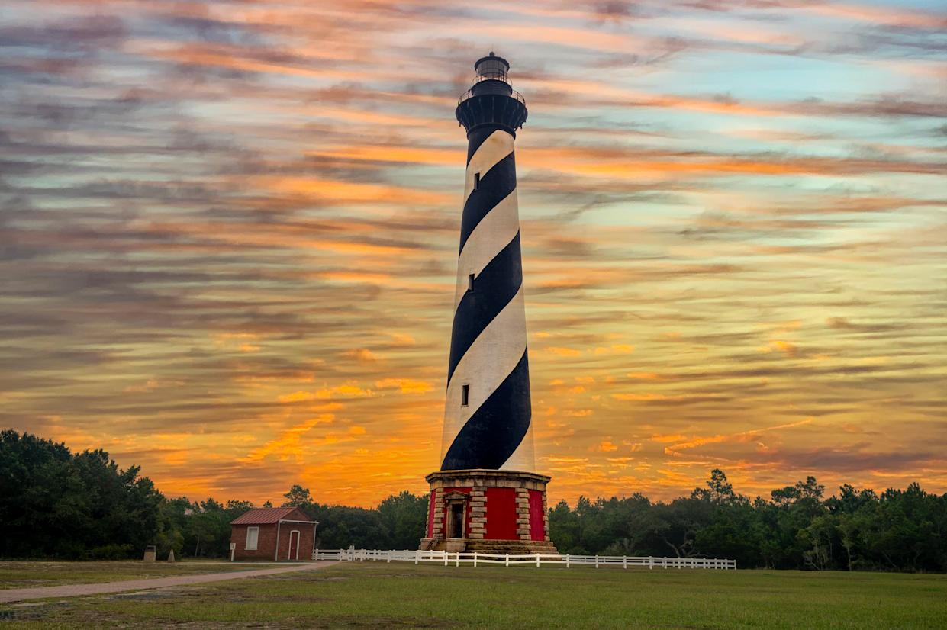
https://www.google.com/url?sa=i&url=https%3A%2F%2Fcreators.yahoo.com%2Flifestyle%2Fstory%2Funforgettable-lighthouses-that-belong-on-your-travel-bucket-list-102750843.html&psig=AOvVaw2gizIG-Fv6JKbSex-q0YjN&ust=1743129191132000&source=images&cd=vfe&opi=89978449&ved=0CBUQjRxqFwoTCMi_ueSiqYwDFQAAAAAdAAAAABAE
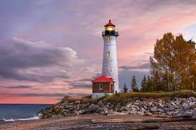
https://www.google.com/url?sa=i&url=https%3A%2F%2Fwww.surfertoday.com%2Fenvironment%2Fwhat-is-a-lighthouse&psig=AOvVaw2gizIG-Fv6JKbSex-q0YjN&ust=1743129191132000&source=images&cd=vfe&opi=89978449&ved=0CBQQjRxqFwoTCMi_ueSiqYwDFQAAAAAdAAAAABAJ

Classic Sailor
Colors and their Hex
#FFFFFF – White
#000000 - Black
#142E57 – Navy Blue
#A60032 – Bright Red
#65CBF9 – Baby Blue
Images Inspirations
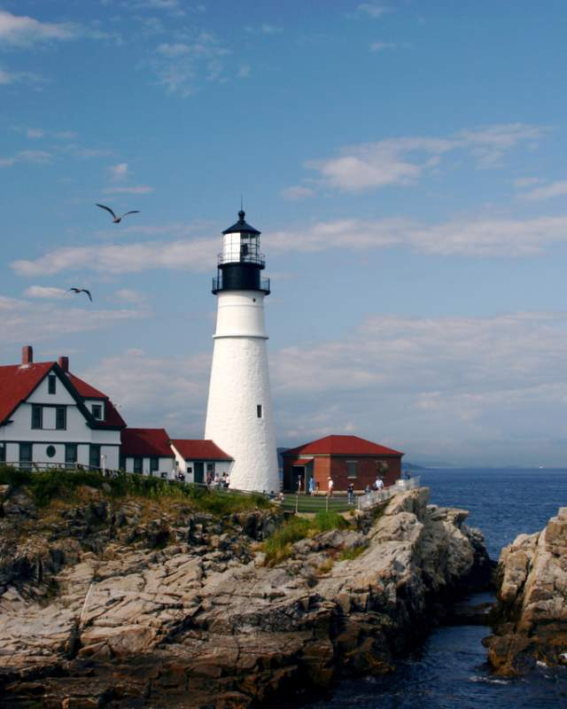
https://www.google.com/url?sa=i&url=https%3A%2F%2Fwww.mainetourism.com%2Fthings-to-do%2Fattractions%2Flighthouses%2F&psig=AOvVaw2gizIG-Fv6JKbSex-q0YjN&ust=1743129191132000&source=images&cd=vfe&opi=89978449&ved=0CBQQjRxqFwoTCMi_ueSiqYwDFQAAAAAdAAAAABAS
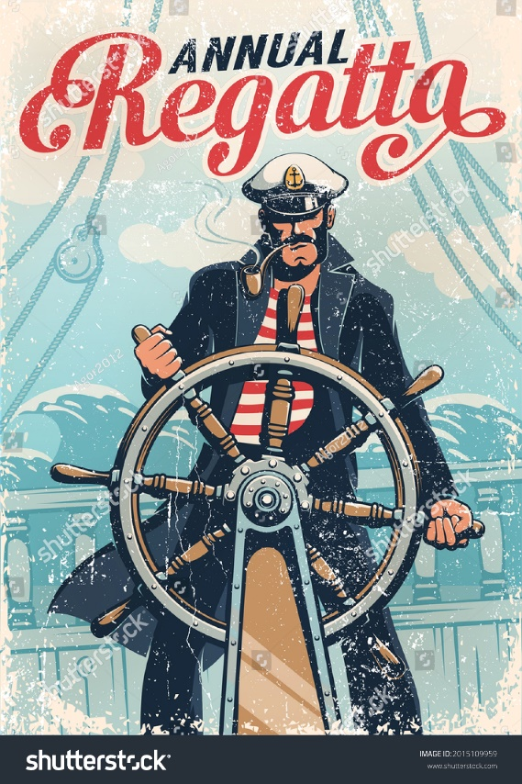
https://www.google.com/url?sa=i&url=https%3A%2F%2Fwww.shutterstock.com%2Fimage-vector%2Fcaptain-sailor-helm-ship-against-background-2015109959&psig=AOvVaw0E9wYnj0behobcCV3x54wd&ust=1743131203972000&source=images&cd=vfe&opi=89978449&ved=0CBQQjRxqFwoTCNimxvajqYwDFQAAAAAdAAAAABAJ

